## Bill Splitter

## Interactive Design Requirements Specification

Version: #3

Date: 2023-02-16

Presented by: Silly Beasts

| Team Member 1’s Name | Will Trimble |
| --- | --- |
| Team Member 2’s Name | Glenn Todd |
| Team Member 3’s Name | Ryan Yocum |
| Team Member 4’s Name | Joe Wesnofske |

# Revision History:

2023-02-02: Initial Version for Deliverable #1

2023-02-09: Completed Sections 5–7 for Deliverable #2

2023-02-16: Completed Sections 8–11 for Deliverable #3

# System Concept

We are developing a mobile app called, “Bill Splitter.” We are marketing towards older college students or young adults that may live in apartments with multiple other people. While using “Bill Splitter,” users will be able to scan a receipt and have the cost broken down into a fair distribution. They will also have the ability to assign the cost of an item to a specific person. Once the bill has been split, the person who made the purchase can send individual requests to be paid back. This will be integrated with multiple apps such as Venmo, Zelle, and CashApp. “Bill Splitter”, will solve problems that many college students are facing right now, such as paying an unfair amount when their roommates are shopping. This web app will also solve the issue of accounting errors that can be made when trying to split the bill. “Bill Splitter” is designed to streamline the hassle of shopping in a group. We believe this will create a better experience for users by being simple to use, and fostering a reliable sense of fairness.

# Interview/Observation Notes

Will interviewed Sammy Deol asking [these questions](https://docs.google.com/document/u/1/d/1wLsVQq7z9-4ikZ9oNIDlynk96_828x5kTedp95t2qTk/edit) and took notes [here](https://docs.google.com/document/u/1/d/1ux0HTIOp1T-E9OxTfAEWLkfutxBHIUY8BT6Nc624UG4/edit).

Ryan interviewed Ben Tinsley asking [these questions](https://docs.google.com/document/u/1/d/1wLsVQq7z9-4ikZ9oNIDlynk96_828x5kTedp95t2qTk/edit) and took notes [here.](https://docs.google.com/document/u/0/d/13JtCKXU3jxNIDyUfJP71kmkOujdgpbQB-v5U_N7VwR4/edit)

Glenn interviewed Rylan Mahany asking [these questions](https://docs.google.com/document/u/1/d/1wLsVQq7z9-4ikZ9oNIDlynk96_828x5kTedp95t2qTk/edit) and took notes [here](https://docs.google.com/document/d/15IUzCTnYDAmLWStQsrlg9CuGQPOIcZvPF_iy00lTw_U/edit).

Joe interviewed Sam Burgoyne asking [these questions](https://docs.google.com/document/d/1wLsVQq7z9-4ikZ9oNIDlynk96_828x5kTedp95t2qTk/edit) and took notes [here](https://docs.google.com/document/d/1fZljeoGz5EfMIf8yYb5HHDk88_R4BnzKuEdAqR3W-7s/edit).

Interviewees were asked the same standard questions listed below. Follow up questions were asked to elaborate on answers given. Interviews were conducted one-on-one with the interviewer also taking notes electronically. Interviewees were of both work roles identified (Bill Splitter and Bill Payer) as users are usually playing either role since who initially pays a bill moves among people in a group.

* How are you splitting bills now?
  + How often
  + What similar/competing applications/techniques do/have you used?
* What bills would you like to split with others?
* How would you like to split the cost of the bill?
  + Percentage
  + By Item
* Who would you like to split bills with?
  + Groups
    - Formation/Management
  + One-Time Users
* How would you like to be paid for bills?
  + Manner of Payment
  + Manner of Notification
* How would you like to pay bills?
  + Manner of Payment
    - Installments?
  + Manner of Notification
* How would you like to input bills to be split?
  + Scan Receipt
  + Electronic Integrations
  + Manual Entry
* What other uses do you see for this application?
  + Subscriptions, Restaurant, etc.
* What problems do you see that could occur?
  + Bill Splitting process
  + Payment process
  + Notifications
* How would you like to contact tech support?
  + Phone

# Work Roles/User Classes

| **Work Role:** | Bill Splitter |
| --- | --- |
| Context of use | The Bill Splitter has paid a bill for a group of people and is now dividing the cost of the bill amongst the other Bill Payers and will send them invoices. |
| Goals | Get Reimbursed for Paying a Group Bill  Split the Costs of the Group Bill Fairly |
| Frequency of use | Used After Paying for a Group’s Bill  Ranges from Monthly to Semi-Weekly Depending on Frequency of Bills |
| Work responsibilities | Divide Costs of the Bill Amongst Bill Payers  Send Invoices to Bill Payers |
| Work environment | Social |
| Abilities | Basic Mobile App Usage  Basic Arithmetic |
| Personal | (Not Limited To) College Students |

| **Work Role:** | Bill Payer |
| --- | --- |
| Context of use | A Bill Payer is reimbursing a Bill Splitter who initially paid for a group’s bill. |
| Goals | Be Assessed a Fair Portion of the Bill  Pay their Share to the Bill Splitter |
| Frequency of use | Used to Reimburse a Bill Splitter After Paying for a Group’s Bill  Ranges from Monthly to Semi-Weekly Depending on Frequency of Bills |
| Work responsibilities | Pay their Share of the Bill |
| Work environment | Social |
| Abilities | Basic Mobile App Usage |
| Personal | (Not Limited To) College Students |

# Work Flow Diagram

When a Bill Splitter pays a bill to be split amongst a group of Bill Payers, the Bill Splitter will from a group that Bill Payers can join. The Bill Splitter inputs a bill, then splits the cost among various Bill Payers. Each Bill Payer will receive an invoice, which they can pay via an integrated online payment service, which will deliver the money to the Bill Splitter.

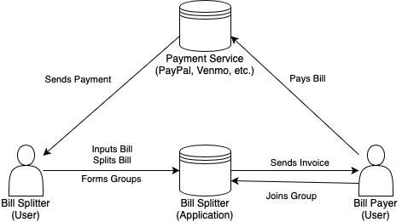

# WAAD

The process went smoothly overall for the first time we all created a WAAD. Everyone coming with our own work activity notes and combining them into final work activities helped make a manageable diagram. The notes naturally organized themselves into major categories, making the final diagram easy to capture.

# 

# Interactive Design Requirements

| **Requirement 1** |  |
| --- | --- |
| Major feature/category name | Bill Splitting |
| Secondary feature/category name | Receipt Input |
| UX requirement statement | A bill splitter should be able to scan a receipt in order to input an itemized bill to be split. [2] |
| [Rationale] |  |
| [Notes] |  |

| **Requirement 2** |  |
| --- | --- |
| Major feature/category name | Bill Splitting |
| Secondary feature/category name | Receipt Input |
| UX requirement statement | A bill splitter should be able to manually enter in items from a receipt in order to input an itemized bill to be split. [2] |
| [Rationale] |  |
| [Notes] |  |

| **Requirement 3** |  |
| --- | --- |
| Major feature/category name | Bill Splitting |
| Secondary feature/category name | Cost Assignment |
| UX requirement statement | A bill splitter should be able to split the cost of the bill among various bill payers according to certain percentages of the bill. [3] |
| [Rationale] |  |
| [Notes] |  |

| **Requirement 4** |  |
| --- | --- |
| Major feature/category name | Bill Splitting |
| Secondary feature/category name | Cost Assignment |
| UX requirement statement | A bill splitter should be able to split the cost of the bill among various bill payers by assigning the costs of particular items to particular bill payers. [4] |
| [Rationale] |  |
| [Notes] |  |

| **Requirement 5** |  |
| --- | --- |
| Major feature/category name | Bill Splitting |
| Secondary feature/category name | Subscriptions |
| UX requirement statement | A bill splitter should receive payment from bill payers for a recurring subscription before the subscription bill is due. [5] |
| [Rationale] |  |
| [Notes] |  |

| **Requirement 6** |  |
| --- | --- |
| Major feature/category name | Groups |
| Secondary feature/category name | Long-Term Groups |
| UX requirement statement | A user should be able to create various groups to split bills with. Users should be able to add and remove themselves and others from groups once formed. [6] |
| [Rationale] |  |
| [Notes] |  |

| **Requirement 7** |  |
| --- | --- |
| Major feature/category name | Groups |
| Secondary feature/category name | One-Time Groups |
| UX requirement statement | Users should be able to form a group for only one bill. After the bill has been split, the group is dissolved. [9] |
| [Rationale] |  |
| [Notes] |  |

| **Requirement 8** |  |
| --- | --- |
| Major feature/category name | Groups |
| Secondary feature/category name | Group Location |
| UX requirement statement | Users should be able to find and join nearby groups based on location data. [8] |
| [Rationale] |  |
| [Notes] |  |

| **Requirement 9** |  |
| --- | --- |
| Major feature/category name | Payment |
| Secondary feature/category name | Payment Methods |
| UX requirement statement | Users should be able to send and receive payments using online payments services such as Venmo, Paypal, Cash App, etc. [10] |
| [Rationale] |  |
| [Notes] |  |

| **Requirement 10** |  |
| --- | --- |
| Major feature/category name | Payment |
| Secondary feature/category name | Payment Methods |
| UX requirement statement | Users should be able to track payments made in-person with cash for split bills. [11] |
| [Rationale] |  |
| [Notes] |  |

| **Requirement 11** |  |
| --- | --- |
| Major feature/category name | Tech Support |
| Secondary feature/category name | Contact Support |
| UX requirement statement | A user should be able to contact tech support 24/7 by call, text, online chat, or email. [12] |
| [Rationale] |  |
| [Notes] |  |

| **Requirement 12** |  |
| --- | --- |
| Major feature/category name | Tech Support |
| Secondary feature/category name | Payment Confirmation |
| UX requirement statement | A user should receive a notification that a payment occurred successfully and be notified of any payment issues. [13] |
| [Rationale] |  |
| [Notes] |  |

# Usability Goals

1. Users will be able to scan a receipt in order to input an itemized bill
2. Users will be able to manually input receipt data if something was missed or not correct
3. Users will be able to split the bill among various payers according to percentages
4. Users will be able to split the bill by item, assigning different items to different people
5. Users will be able to receive payment from bill payers for recurring subscriptions
6. Users will be able to form groups to split bills with
7. Users will be able to form single use groups that will be dissolved after the bill has been split
8. Users will be able to search for nearby groups, allowing people to quickly join a group when they are together.
9. Users will be able to receive online payments through cash app, venmo, paypal, etc
10. Users will be able to pay with cash and have their payment marked as complete.
11. Users will be able to contact tech support 24/7 through call, text, and email
12. Users will receive notifications about payment updates or issues.
13. New users will be able to successfully pay a bill the first or second time they try.

# User Classes

| **Work Role:** | Bill Splitter |
| --- | --- |
| Context of use | The Bill Splitter has paid a bill for a group of people and is now dividing the cost of the bill amongst the other Bill Payers and will send them invoices. |
| Goals | Get Reimbursed for Paying a Group Bill  Split the Costs of the Group Bill Fairly |
| Frequency of use | Used After Paying for a Group’s Bill  Ranges from Monthly to Semi-Weekly Depending on Frequency of Bills |
| Work responsibilities | Divide Costs of the Bill Amongst Bill Payers  Send Invoices to Bill Payers |
| Work environment | Social |
| Abilities | Basic Mobile App Usage  Basic Arithmetic |
| Personal | (Not Limited To) College Students |

| **Work Role:** | Bill Payer |
| --- | --- |
| Context of use | A Bill Payer is reimbursing a Bill Splitter who initially paid for a group’s bill. |
| Goals | Be Assessed a Fair Portion of the Bill  Pay their Share to the Bill Splitter |
| Frequency of use | Used to Reimburse a Bill Splitter After Paying for a Group’s Bill  Ranges from Monthly to Semi-Weekly Depending on Frequency of Bills |
| Work responsibilities | Pay their Share of the Bill |
| Work environment | Social |
| Abilities | Basic Mobile App Usage |
| Personal | (Not Limited To) College Students |

# 9. Design Modeling - Social Model Diagram

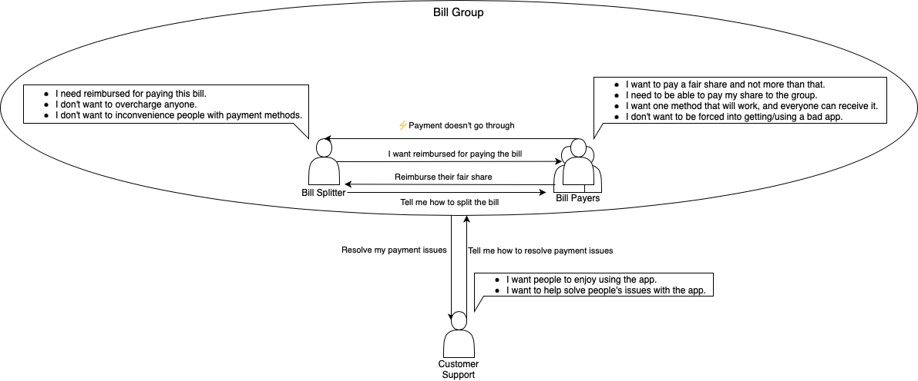

Primarily, this social model focuses on the social pressures between the Bill Splitter and Bill Payers. Their primary concern is paying/receiving their fair share of reimbursement for the bill being split. There is also some concern about using a technically sound app and that payment goes through successfully. To help resolve technical concerns, customer support representatives are available.

1. **Design Modeling - Usage Scenarios**

## After a Costco run with roommates, you will be able to scan the receipt into the app. From here you can see all the items bought and how much each item was. Then you can split the bill and find the price breakdown.

## You are going out for dinner with friends, once the bill comes out you realize that some people ordered more expensive dinners than others. You pull out your phone and open the Bill Splitter, and scan the receipt into the app. Manually adding individual items that are individual to the restaurant. This ensures that everything the restaurant serves can be added to the Bill Splitter.

1. You go to Wegmans to buy groceries with your two roommates. One person pays for everything at the store. Upon getting back to the apartment, the bill payer can scan and manually enter the bill. From here, each item is assigned to different people based on what they bought. Since all 3 roommates are splitting the milk, you can assign the item to all the roommates. The bill payer can also split the overall bill by percentage.
2. After a big dinner with your friends, you break down the costs of the receipt, you are going to send requests for my payments to each person involved. These requests can be sent through multiple payment apps such as Venmo, Cashapp, PNC.
3. Before you go out, you are going to create a group of users. This group of users can be as big as you would like, you also have the option to make a one time use group. You can also create a group based on location. Once you get home, you split the bill and send notifications to everyone in the group.

# Design Modeling - Task Analysis

1. **Split Grocery Bill**
   1. Scan Receipt into App
   2. Split Costs
      1. Examine Each Item
         1. Assign Cost of Item to Specific Bill Payer
      2. Show Final Price Breakdown

Plan 1: Do all items/subitems in order.

1. **Splitting Restaurant Bill**
   1. Scan Receipt into App
   2. Assign Individual Item Costs to Individual Bill Payers

Plan 2: Do all items/subitems in order.

1. **Splitting Grocery Bill**
   1. Enter Bill
      1. Scan Bill
      2. Manually Enter Bill
   2. Split Costs
      1. Split Costs by Assigning Items
         1. Assign Item to Individual
         2. Assign Item to Group
      2. Split Costs by Percentage

Plan 3: Do item 3.1 by doing either item 3.1.1 or 3.1.2. Then, do item 3.2 by doing either sub items. Do item 3.2.1 by doing either subitems for each item in the bill.

1. **Request Payment Method**
   1. Split Costs
   2. Send Payment Request to All Bill Bayers
      1. Request Payment via Venmo
      2. Request Payment via Cahapp
      3. Request Payment via PNC

Plan 4: Do item 4.1, then any subitem under 4.2 for each bill payer.

1. **Create Group**
   1. Decide Group Duration
      1. Long-Term Group
      2. One-Time Group
   2. Add Users to Group
      1. Add Users by Location
   3. Split Bill
   4. Send Bill Notifications

Plan 5: Do item 5.1 by doing either subitem. Then do item 5.2, optionally by doing item 5.2.1. Then do items 5.3 and 5.4